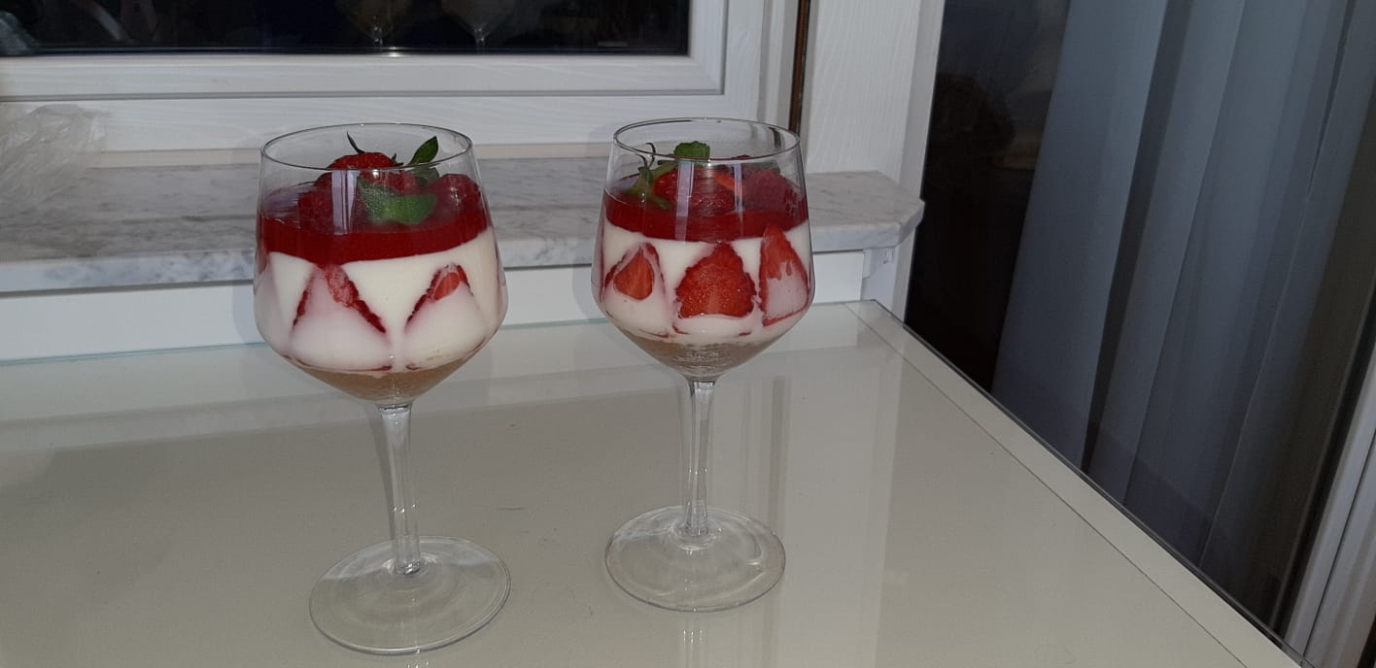

F.R.

II D - ICVIACRIVELLI – TOSCANINI

This recipe besides making you cook a delicious dessert also makes you have fun !!

Cooking it was an experience to remember that allowed me to spend more time in the kitchen and discover this new culinary world foreign to me so far.

I discovered a new passion that I hope will share with you !!

I invite you to try it and discover a new interest.

Good luck and enjoy!

INGREDIENTS: CHEESECAKE

Digestive Biscuits 100 g

Butter 65 g

FOR THE YOGHURT CREAM

Creamy natural white yoghurt 250 g

Liquid fresh cream 70 g

Whole milk 35 g

Jelly in sheets 7 g

Vanilla pod ½

Icing sugar 30 g

Strawberries (not very large) 150 g

FOR COULIS

Strawberries 100 g

Icing sugar 100 g

Cornstarch (cornstarch) 10 g

Lemon juice ½

TO DECORATE

Strawberries q.b.

Mint q.b.

Blueberries q.b.

Raspberries q.b.

RECIPE: CHEESECAKE

To prepare the cheesecakes in the jar, start by soaking the gelatine in cold water.

Then continue with the base of dry biscuits: melt the butter.

Meanwhile blend the biscuits and pour the crumbs into a bowl, add the melted butter. and stir to create a fairly homogeneous compound.

Then pour the biscuit mixture into the jar and create a compact layer with the back of a teaspoon.

Close the jars and put them in the fridge.

In the meantime, scrape off the vanilla berry seeds and set them aside.

Pour the milk into a saucepan and heat without it reaching boiling point.

Turn off and add the gelatine draining the excess water, mix well to dissolve it and let it cool down.

In the meantime whip the cream.

In another bowl pour the cream together with the seeds extracted from vanilla and icing sugar.

Start the whips at medium speed and get a soft cream (the cream should not be whipped stiffly).

Set aside while you pour the white yoghurt into another bowl.

Add the lukewarm milk and stir well, then add the semi-whipped cream and stir again but gently.

At this point the cream is ready.

Take the jars from the fridge and take care of the interior decoration, clean the strawberries by removing the stalks and cut into slices of about 7-8 mm.

Place them inside the jars in a vertical position, covering the inside: gently squeeze the strawberries towards the glass Pour the cream until you cover everything, close the jars and put them in the fridge for at least 2 hours Take care of the coulis.

Peel the strawberries and cut them into 25 pieces, pour them into the pan together with the corn starch, lemon juice and sugar.

Mix well, turn on the stove and leave to cook for about ten minutes over high heat.

The time needed to soften the strawberries, then transfer them to a sieve placed inside a bowl and sieve.

Here's the jelly ready, let it cool down.

Take the jars, open them and pour the dense mixture on the surface.

If you want you can put the jars back in the fridge or consume them immediately.

But don't forget to garnish with berries, strawberries and a little mint first. Here are your cheesecakes ready in the jar!

The longer they stay, the more compact the cream will be, so the cream will not go to cover them.